May 13th, 2007
Hi
Well, first of all, its ‘Happy Birthday’ to Gavin tomorrow. Take your pick of birthday cards!

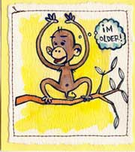


For exercise this past week. I swam three times, doing a total of 4.5 km, which, interestingly, is the same as for this week last year. However, with a total of 2 hr 20 min for skipping plus weights and two 15-min runs, I did far more exercise than for last year. I ended the week a bit tired, so will do less exercise next week. (I think I said that last week too!)
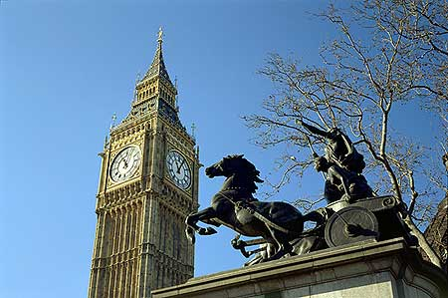
Watched an interesting TV documentary about the Celts. I have always been curious as to who they actually were. If the person investigating them is correct, ‘Celts’ is a term given by the ancient Greeks to a people who lived in the middle of Europe. The ideas, art, warring methods and aspects of their language spread across Europe and were adopted by others. So ‘Celts’ seems to refer to a culture rather than a people. Even the Irish in particular, who use the term, are not actually ‘Celtic’ and their genes are quite distinct from people in Europe. Welsh ‘Celts’ have linguistic similarities in the Welsh language. And the kind of chariot that Queen Boadicaea (or Boudica to use her more correct name) in eastern England used against the Romans in AD 60 (see picture) was similar to those in European countries, but she too was not Celtic.

I went to the dermatology clinic again on Thursday morning. Again, nothing new. The Lantau cable car broke down again stranding hundreds of people. To try to reduce the waste from plastic bags, the government is to introduce a 50-cent fee for each plastic bag sold, starting with supermarkets and gradually extending it to other establishments. Wet markets will be exempt.
Nadine, I received your postcard the other day. Interesting. So it looks as if you will be returning in June rather than being able to extend your stay for another term. Let me know the dates you will be here.
Gavin, got your e-email about ‘retiring’ in NZ. I have thought about it but where? Once you suggested Wanaka; beautiful, and probably OK for running, but too small. Also, there is little access to services that I get here in HK, such as being able to go regularly to clinics/hospitals for checkups, medicine, dentist, etc. A larger place, such as Christchurch, would be better; but the South Island is cold in winter!

The semi-finals of the Super 14 were played this weekend. There were two NZ sides (Crusaders and Auckland Blues) and two SA sides. Both SA sides (who were playing the NZ sides) won, so this year will see the first all SA final.
That’s it for now.
Cheers

